DEPARTMENTS AND EMPLOYEES MANAGEMENT

PROIECT SCD

Autor: Pastinaru Dorin

Profesor:Dr. Ing. Octavian Cuibus

1)Application Diagram

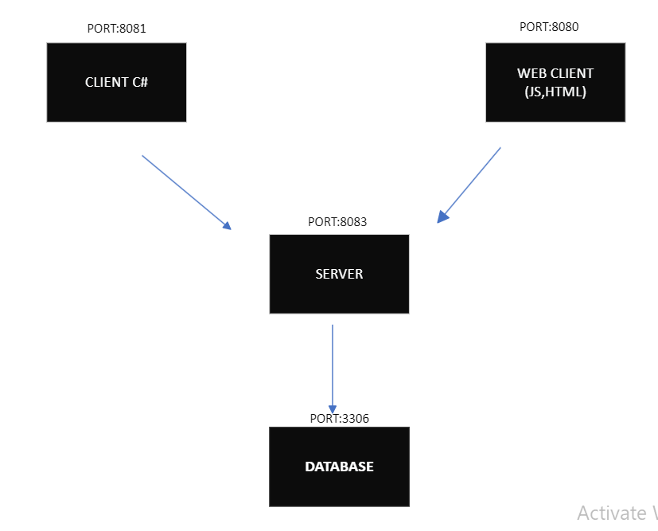

Port 3306

Port 8080

2)Server Diagram

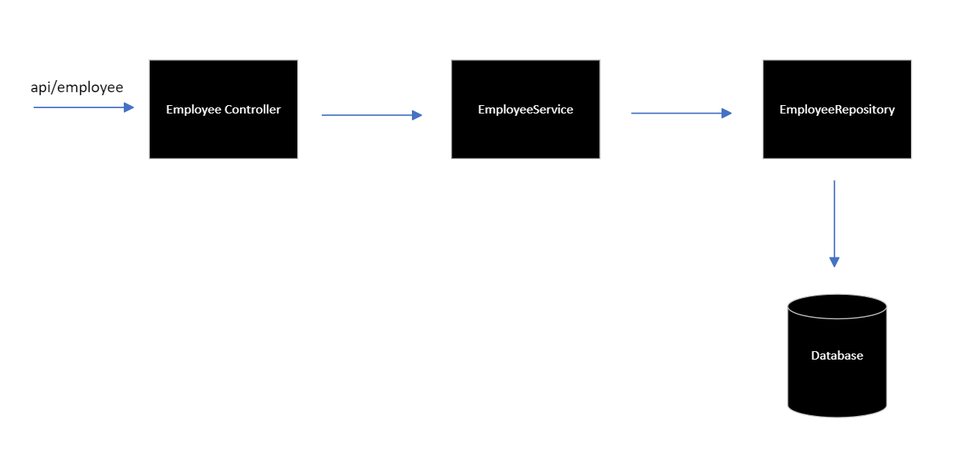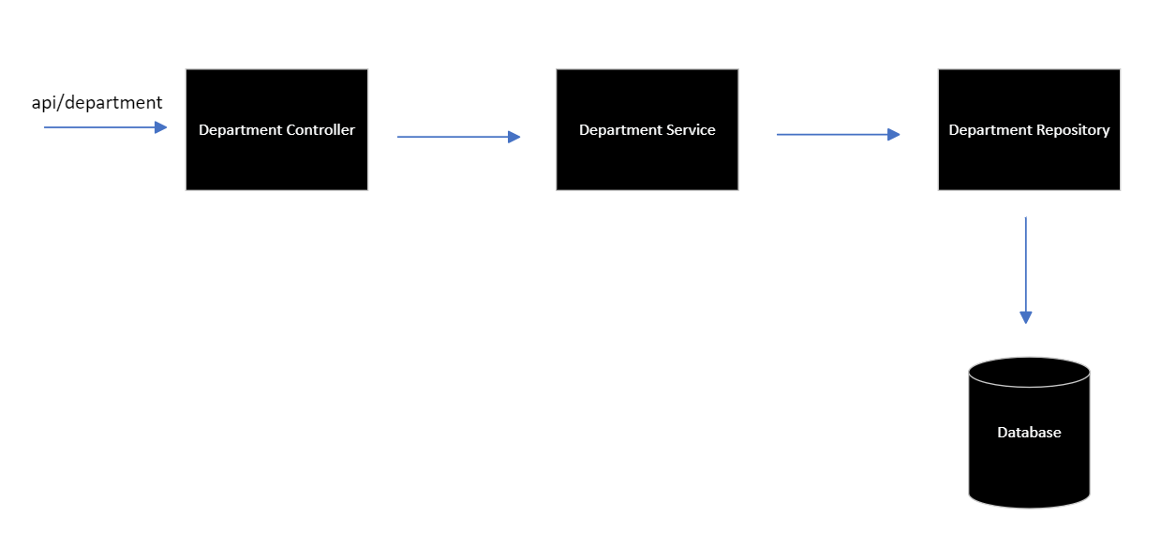

3)Use Case Diagram

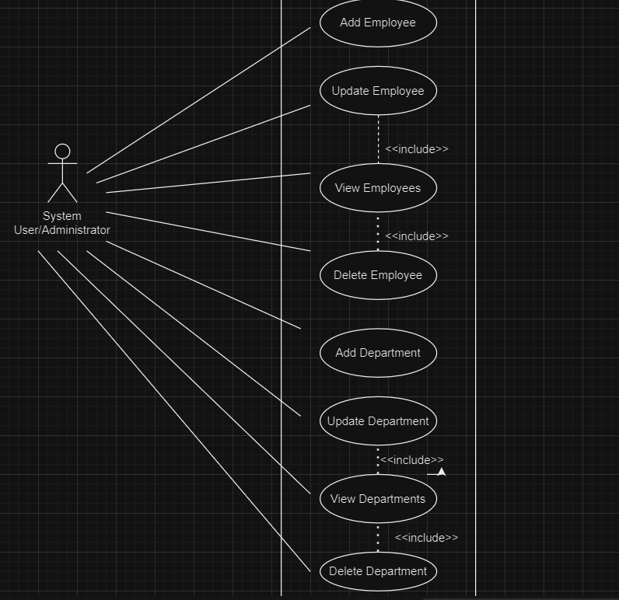

4)’]  
Class Diagram

